First Look at MDS 3.0 Version 1.17 Questions Asked During March 14 & 15, 2019 Webinars Mary Madison, RN, RAC-CT, CDP Clinical Consultant – Briggs Healthcare®

COMMENT: This is not a question but rather just a statement/comment. Thank you for saying that the mds coordinator(s) is/are needed more than ever, because it seems like administration(s) are thinking since mds assessments are less, that the mds nurses will have plenty of time to do other things.
RESPONSE: You’re welcome! It’s true! While the frequency of PPS assessments has been greatly reduced, the need for monitoring the resident’s condition during the skilled stay, in my opinion, will be increasing with PDPM reimbursement. MDS Coordinators and Reimbursement Specialists will need to keep a keen eye on resident status and know when an Interim Payment Assessment is needed. IPAs are optional but can positively (negatively, if not done when warranted) impact reimbursement for skilled care.

QUESTION: Will we be continuing doing MDS for Med A with the 5 day, 14 day, 30 day and so on?
ANSWER: In most cases on and after October 1, 2019, a facility will complete and transmit only a 5-day PPS assessment to set the rate for the entire skilled stay. On that date, we will no longer be completing any other scheduled PPS assessment, with the exception of the NPE – End of Part A PPS Discharge Assessment. Gone are the unscheduled OMRA assessments known as COT, SOT, EOT and EOT-R.

QUESTION: Will the 5 day be more of a comprehensive then the rest of the Med a's?
ANSWER: The 5-day PPS assessment will be similar to the 5-day we are doing now with the new items and changes I presented during this webinar.

QUESTION: Combine obra admission and 5 day?
ANSWER: I’m sure the draft RAI User’s Manual, expected to be released by CMS in early May, will allow this combination. I see no reason why it would not. Let’s check that in Chapter 2 of the MDS 3.0 RAI User’s Manual when it’s posted.
QUESTION: Is the section for Recreational Therapy removed from Special Treatments?
ANSWER: It has not been removed from the DRAFT MDS 3.0 Item Set, version 1.17. O0400F is still there.

QUESTION: Any changes regarding Section F?
ANSWER: There are no changes in Section F in the DRAFT version.

QUESTION: A0300 in the Optional State Assessment, if MDS is combined for Quarterly and Medicare, is the response No or Yes. We are State Case Mix.
ANSWER: The fundamental answer to this question will need to be answered by each state that is a case-mix state. These states will decide individually if they are going to use the OSA to determine Medicaid case-mix reimbursement from October 1, 2019 through September 30, 2020. Contact your state’s MDS Automation Coordinator of Medicaid office for that answer.

QUESTION: Why would you use an OSA instead of a quarterly or sig change?
ANSWER: The OSA (Optional State Assessment) has been provided by CMS for states to consider/use for Medicaid case-mix reimbursement as described in the above answer. I’m certain providers in case-mix states will receive more information as we get closer to summer and fall.

QUESTION: When do you complete an OSA? Please give us an example.
ANSWER: Please see my response to the above 2 questions.

QUESTION: Will there be a video recording to hear this again or just the slide handouts to use?
ANSWER: https://attendee.gotowebinar.com/register/2474819651837788675 is the link to the recording. https://briggshealthcare.blog/2019/03/14/webinar-materials-first-look-at-mds-3-0-version-1-17/ is the link to the handouts.
QUESTION: Would you please clarify/repeat your comments re: section K. Will we be able to capture IVF received while in hospital for Nursing PDPM bucket if received during past 7 days? Can you please clarify- can only code Mechanically altered diet, etc. if did not have prior to admission, is that correct?
ANSWER: Yes, IV fluids received while not a resident and within the last 7 days of the ARDs look-back period will be coded; mechanically altered diet will not be coded prior to the resident receiving care in your facility:
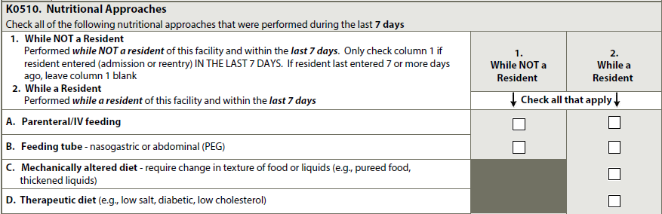
QUESTION: Can MDS Coordinator go to RAI panel directly if unable to get specific answers to questions submitted? For example-if referred to read RAI manual but already have many times and still have uncertainty.
ANSWER: I would encourage you to email your question to your State’s RAI Coordinator as clearly as possible. If you are still uncertain about the answer you received, I would suggest you ask your State RAI Coordinator to submit the scenario to CMS directly if he/she hasn’t already. Another option is to inquire if you may submit to CMS directly (courtesy request).

QUESTION: Can an IPA be completed for an interrupted stay when the patient returns?
ANSWER: Generally speaking, that’s not what the IPA is used for. CMS posted a PDPM Fact Sheet on Interrupted Stay. That 2-page document is found at: https://www.cms.gov/Medicare/Medicare-Fee-for-Service-Payment/SNFPPS/Downloads/PDPM_Fact_Sheet_InterruptedStay_Final_v3_508.pdf. The Interrupted Stay Policy sets out criteria for determining when Medicare will treat multiple SNF stays occurring in a single Part A benefit period as a single “interrupted” stay, rather than as separate stays, for the purposes of the assessment schedule and the variable per diem. CMS defines an “interrupted” SNF stay as one in which a patient is discharged from Part A covered SNF care and subsequently readmitted to Part A covered SNF care in the same SNF (not a different SNF) within 3 days or less after the discharge (the “interruption window”). I encourage you to review and share that Fact Sheet. You’ll also find additional information and specific examples on slides 66 – 70 of SNF PPS: Patient Driven Payment Model.
QUESTION: Are you going to come out with a draft edition of Briggs RAI manual?
ANSWER: Briggs is going to do that! Our goal, as is CMS’ goal, is to get the MDS 3.0 RAI User’s Manual, version 1.17, into the hands of our customers/providers shortly after its release so you and your team can start reviewing the guidance that will be effective with the Item Set on October 1, 2019. Watch Briggs emails as well as BNN posts and our MDS manual website for availability.

QUESTION: Have you heard whether CMS will specify the criteria for determination of whether to complete an IPA or not or will they leave that decision up to the Providers?
ANSWER: In short, CMS is telling us now that the IPA is optional. I believe that there will be more guidance in the RAI User’s Manual that is slated for release in early May. I’ll be looking for that guidance as well! https://www.cms.gov/Medicare/Medicare-Fee-for-Service-Payment/SNFPPS/PDPM.html#resources is a CMS PDPM website that you’ll want to bookmark and access for questions/answers.
On that same website, you’ll find https://www.cms.gov/Medicare/Medicare-Fee-for-Service-Payment/SNFPPS/Downloads/PDPM_FAQ_Final_v2_508.pdf - an FAQ document as of February 14, 2019. Page 19 of the FAQ speaks to a hard transition on October 1st to PDPM by completing an IPA that 1st week. Keep your eyes open for more information on that transition from RUGs -> PDPM.
The DRAFT IPA Item Set is 21 pages in length and contains the items that are included in PDPM calculations. That as well as the other DRAFT v1.17 Item Sets are found at: https://www.cms.gov/Medicare/Quality-Initiatives-Patient-Assessment-Instruments/NursingHomeQualityInits/NHQIMDS30TechnicalInformation.html.

QUESTION: Do we still do Advantage MDS and not submit?
ANSWER: CMS has given no indication that this policy is changing, and I don’t anticipate that it will change. You’ll complete MDS assessments for Medicare Advantage/Managed Care just as you do now and NOT submit them, just as you do now. I’ll let our BNN Blog readers know if that changes. The early release of the v1.17 RAI Manual will likely speak to transmitting all OBRA assessments and only PPS assessments for traditional Medicare A beneficiaries.

QUESTION: Do the RTP codes affect the nursing groups?
ANSWER: https://www.cms.gov/Medicare/Medicare-Fee-for-Service-payment/SNFPPS/therapyresearch.html is the website to find the spreadsheet where RTP (Return to Provider) codes are identified, if you want to see which diagnoses codes are identified within PDPM and their mapping to clinical categories. Scroll down the page to SNF PDPM Clinical Category Mapping to open that spreadsheet.

QUESTION: I0020B--reason resident is in facility for care--you mean the reason that they are there for the SKILLED MedA stay, right? that may or may not be the same reason that the resident resides at the SNF. I feel that the way it is being stated by educators is confusing, or else I am totally misunderstanding.
ANSWER: Correct. The primary reason for the admission for skilled care or within the skilled stay, the reason for completing an IPA. Down the road, the primary reason for continued stay at a skilled level could be different – thus the IPA. Further down the road, the primary diagnosis for continued stay at a lower level of care (NF) can and is often different. At that time, those active diagnoses are identified in I0100 -> I8000.
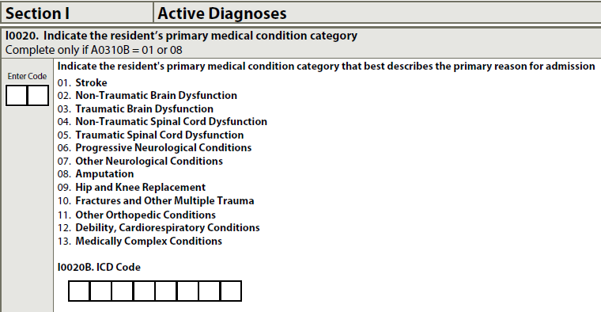

QUESTION: In point system for NTA Diagnosis: So if the resident has 4 different sites of Stage 4 pressure ulcer do we code it in 4 different ICD10? Then do we get 4 different points in that?
ANSWER: That’s a question for a PDPM webinar. From my research and this CMS PDPM Fact Sheet: https://www.cms.gov/Medicare/Medicare-Fee-for-Service-Payment/SNFPPS/Downloads/PDPM_Fact_Sheet_NTAComorbidityScoring_v2_508.pdf, I would say only 1 point. Sites aren’t captured in M0300.
QUESTION: I've heard several times that in PDPM we don’t have to do a Discharge Return Anticipated (if resident sent to ER and return within 3 days)? What about the OBRA DCRA and Entry Tracking?
ANSWER: I have not heard or seen any direction to not complete a discharge assessment when there is an interrupted stay. I can’t imagine CMS not requiring a discharge and subsequent re-entry when the resident is out of your facility. https://www.cms.gov/Medicare/Medicare-Fee-for-Service-Payment/SNFPPS/Downloads/PDPM_Fact_Sheet_InterruptedStay_Final_v3_508.pdf is a CMS Fact Sheet on Interrupted Stay. https://www.cms.gov/Medicare/Medicare-Fee-for-Service-Payment/SNFPPS/Downloads/MLN_CalL_PDPM_Presentation_508.pdf slides 66 - 70 address this as well.
is an item on the OBRA Discharge Item Set.
Let’s watch for such direction in the RAI Manual that will be released in early May.

QUESTION: Have you heard what is going to happen to the MSHO and other insurance carriers with this new MDS?
ANSWER: I have not heard that anything is changing with other insurance carriers.

QUESTION: How do you think CMS will view a facility that requests a number of corrections that result in a better rate. In other words if they don't get all the info originally and then modify later.
ANSWER: I don’t think CMS will view MDS corrections differently than they do at the present time or have in the past. If there is an error on an accepted MDS, the provider should modify the accepted assessment so that the correct information is in the national database. As always, you should ensure that you have the supporting documentation for any corrections you process.

QUESTION: Do you have a "Live" ICD-10 Training coming up soon?
ANSWER: Stay tuned – we’re looking at such an offering!
QUESTION: If an MDS nurse forgets to enter a diagnosis on the 5day will we be allowed to modify the 5day to add the diagnosis and then will we be allowed to adjust the payment?
ANSWER: I don’t believe CMS is changing the current policy of processing modifications to accepted MDS assessments to ensure accuracy of the data. Let’s watch for the posting of the v1.17 RAI Manual in early May to see if that remains the same or is changing due to PDPM. My money’s on that it will not change.

QUESTION: What are the conditions to initial IPA assessment? Is IPA just to increase reimbursement? What happens when resident did not have therapy for 3 days due to worsen medical condition?
ANSWER: I believe that there will be more guidance in the RAI User’s Manual that is slated for release in early May. I’ll be looking for that guidance as well! https://www.cms.gov/Medicare/Medicare-Fee-for-Service-Payment/SNFPPS/PDPM.html#resources is a CMS PDPM website that you’ll want to bookmark and access for questions/answers.
On that same website, you’ll find https://www.cms.gov/Medicare/Medicare-Fee-for-Service-Payment/SNFPPS/Downloads/PDPM_FAQ_Final_v2_508.pdf - an FAQ document as of February 14, 2019. Page 19 of the FAQ speaks to a hard transition on October 1st to PDPM by completing an IPA that 1st week. Keep your eyes open for more information on that transition from RUGs -> PDPM.

QUESTION: I realized if BIMS has been dashed (in our updated EHR) then the SLP rug will not calculate and no HIPPS code. I'm not sure if this is an error in our EHR.
ANSWER: That’s a great question to pose to your EHR vendor. EHR vendors are working on PDPM programming as we speak.

QUESTION: For Revised Item J1800- Any Falls Since Admission/Reentry. Does it mean that if a resident who had a fall before transferring to an ER (in which we already coded on the DC Assessment), then If we do the 5D MDS, does it mean we don’t have to code it in J1800, anymore?
ANSWER: The only thing that’s changing with J1800 is the skip pattern if the resident had any prior falls. This and version 1.17 still require falls to be encoded if the happened since admission/entry, reentry or the prior assessment – the most recent. You will code these occurrences just as you do now.
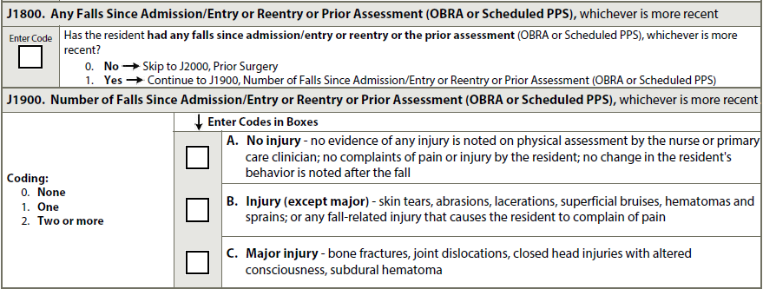

QUESTION: I have heard that payment will be affected by Speech Therapy for dysphagia when combined with a mechanically altered diet. Some dietitians have a difference of opinion on what constitutes "mechanically altered." just wondering if CMS will go into detail since payment will be impacted.
ANSWER: I love a good clinical discussion whether it be between nurses, dietitians, therapists, etc. We can all have differences of opinion, but when it comes to encoding the MDS Item Set, we have to look to CMS’ definition of mechanically altered. That definition is found in Chapter 3, Page K-11 of the current RAI Manual. It is: “A diet specifically prepared to alter the texture or consistency of food to facilitate oral intake. Examples include soft solids, puréed foods, ground meat, and thickened liquids. A mechanically altered diet should not automatically be considered a therapeutic diet.” The RAI Manual is our IDT guide to what we enter on the MDS.
Let’s watch and see if CMS changes this definition in the RAI Manual that they post in early May.

